**Overview**

A school district had asked for data analysis of several key metrics at each school and the district. The main analysis focused on the performance of math and reading scores changed in several ways which were in preparation for a board meeting. Moreover, after the school board reviewed the data, it was determined that the data from Thomas High School's 9th-grade class was suspected of cheating/malpractice. The school board had asked for this particular data set to be removed and analyzed again for a comparison.

**Results**

**How is the district summary affected?**

[](https://github.com/Baylex/School_District_Analysis/blob/main/Resources/1_dist_sum_2_decimals.PNG)

The testing data of 461 of the 9th grader students at Thomas High School were turned into null data.

[](https://github.com/Baylex/School_District_Analysis/blob/main/Resources/2_dist_sum_2_decimals.PNG)

In comparison to the two charts, removing less than 500 test scores had a nominal impact on the almost 40,000 student data set.

**How is the school summary affected?**

Original Analysis: [](https://github.com/Baylex/School_District_Analysis/blob/main/Resources/2_THS_90.PNG)

Changed Analysis: [](https://github.com/Baylex/School_District_Analysis/blob/main/Resources/2_THS_65.PNG)

Removing the 9th-grade students from the data set had a huge impact by dropping from 91% to 65% the overall passing rate.

**How does replacing the ninth graders’ math and reading scores affect Thomas High School’s performance relative to the other schools?**

Original Analysis: [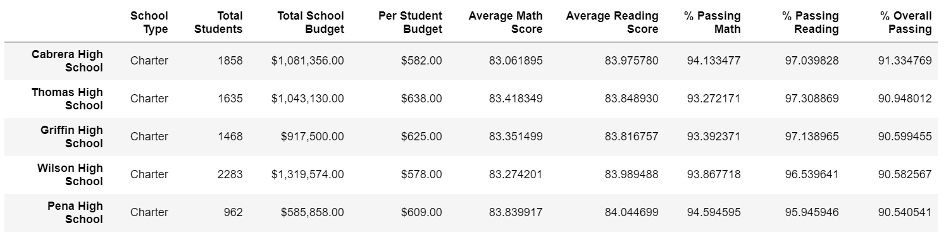](https://github.com/Baylex/School_District_Analysis/blob/main/Resources/1_top_5_schools.PNG)

Adjusted Analysis: [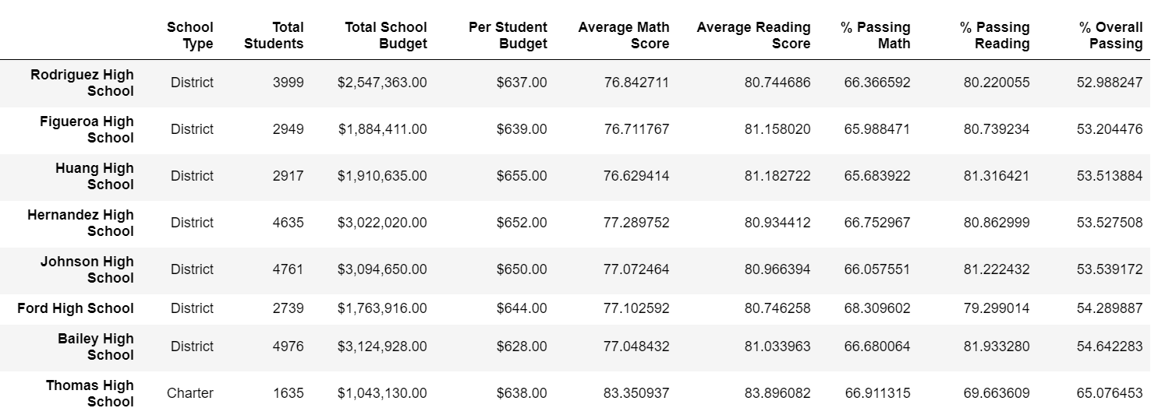](https://github.com/Baylex/School_District_Analysis/blob/main/Resources/2_bottom_8_schools.PNG)

**Scores by school spending**

Thomas High School falls in the $630-$644/student spending range. However, the hundredth place was needed to see the nominal changes.

Original Analysis: [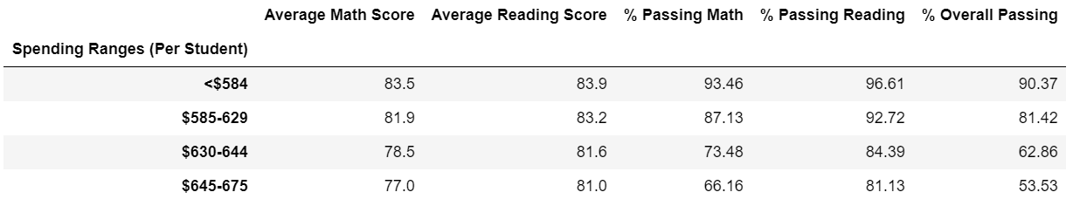](https://github.com/Baylex/School_District_Analysis/blob/main/Resources/1_spend_updated.PNG)

Adjusted Analysis: [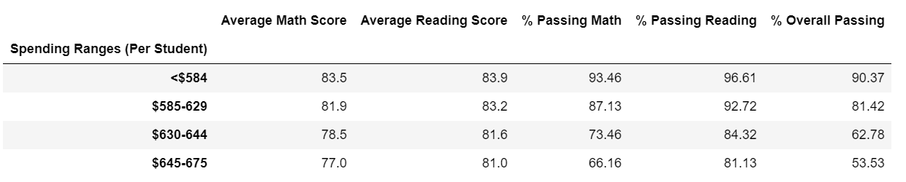](https://github.com/Baylex/School_District_Analysis/blob/main/Resources/2_spending_updated.PNG)

There was very little spending impact by changing the 9th-grade scores.

**Scores by school size**

Original Analysis: [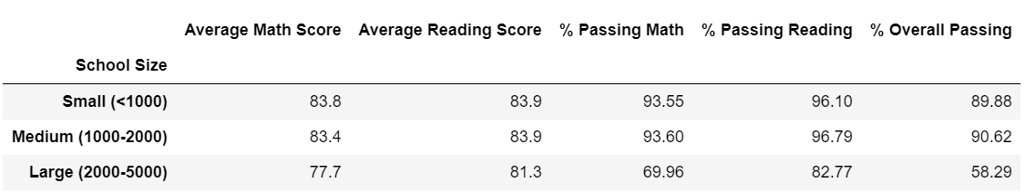](https://github.com/Baylex/School_District_Analysis/blob/main/Resources/1_size_updated.PNG)

Adjusted Analysis: [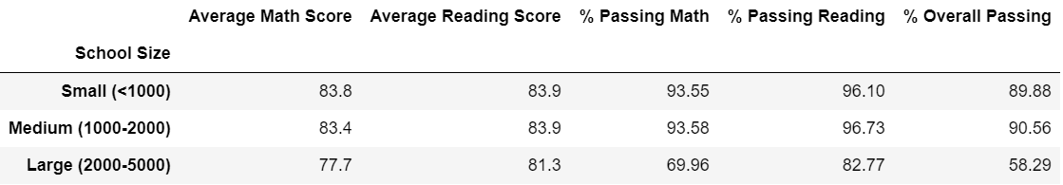](https://github.com/Baylex/School_District_Analysis/blob/main/Resources/2_size_updated.PNG)

There was very little impact by campus size due to changing the 9th-grade scores.

**Summary:**

The overall passing rate for Thomas High School changed dramatically from 91% to 65%.